**Birla Institute of Technology & Science, Pilani**

**Work Integrated Learning Programmes Division**

**First Semester 2023-2024**

**Mid-Semester Test**

**(EC-2 Regular)**

Course No. : BITS ZG553

Course Title : REAL TIME SYSTEMS

Nature of Exam : Closed Book

Pattern of Exam : Typed Only

Weightage : 30%

No. of Pages = 7

# ***No. of Questions =***

Duration : 2 Hours

Date of Exam : 22/09/2023(FN)

Note to Students:

1. Please follow all the *Instructions to Candidates* given on the cover page of the answer book.
2. All parts of a question should be answered consecutively. Each answer should start from a fresh page.
3. Assumptions made if any, should be stated clearly at the beginning of your answer.

**Q.1 Set. (A)**

For the following 6 Questions, chose the most appropriate (single) answer and write ONE/TWO LINE justification (No Marks for wrong/invalid justification, even if your choice is correct). [ 6M = 6 X 1M]

1.1 Pre-emptive, Priority-based Scheduling algorithms guarantees:

1. Hard Real Time (HRT) functionality always
2. Soft Real Time (SRT) functionality always
3. HRT functionality only for multiprocessor systems
4. Faster Response times for all tasks

1.2 In Real Time Systems, Interrupt Latency need to be:

1. Minimum to enhance response time
2. Maximum to avoid deadlocks
3. Optimal for greater CPU utilization
4. None of the above

1.3 Identify the correct statement from the below:

1. Deadlocks can’t occur in Hard RT systems
2. Most of the embedded systems are RT systems
3. Priority of Tasks can be changed during run-time in cyclic scheduler
4. Performance of Soft-RT systems can be measured by Average Response Time

1.4 Which of the following is a non-preemptive scheduling algorithm used in Batch Systems:

1. Least Slack Time (LST) first
2. Shortest Response Time (SRT) first
3. First-Come-First-Served
4. Priority-Based

1.5 Which of the below applications is a Hard Real Time System:

1. Multiplayer Video Gaming console
2. Automated Teller Machine
3. Automated Driver Assistance System (ADAS) in Automobiles
4. Web Server

1.6 To improve the average response times for soft-RT aperiodic tasks, we can adopt the following approach:

1. EDF
2. Round Robin
3. Shortest Job First
4. Periodic Servers

**Q.1 Set. (B)**

For the following 6 Questions, chose the most appropriate (single) answer and write ONE/TWO LINE justification (No Marks for wrong/invalid justification, even if your choice is correct). [ 6M = 6 X 1M]

1.1 Priority and Non pre-emptive based Scheduling algorithms guarantees:

1. Hard Real Time (HRT) functionality always
2. Soft Real Time (SRT) functionality always
3. HRT functionality only for multiprocessor systems
4. Faster Response times for all tasks

1.2 In Real Time Systems, Interrupt Latency need to be:

1. Less than the Task-switching time
2. As small as possible for good response
3. Optimal for greater CPU utilization
4. None of the above

1.3 Identify the correct statement from the below:

1. Deadlocks can occur in Hard RT systems
2. Most of the embedded systems are RT systems
3. Priority of Tasks can be changed during run-time in cyclic scheduler
4. Performance of Hard-RT systems can be measured by Average Response Time

1.4 Which of the following is a preemptive scheduling algorithm used in Time-sharing Systems:

1. Least Slack Time (LST) first
2. Shortest Response Time (SRT) first
3. First-Come-First-Served
4. Weighted Round-Robin

1.5 Which of the below applications is a Hard Real Time System:

1. Multiplayer Video Gaming console
2. Automated Teller Machine
3. Anti-lock Braking Systems in cars
4. Web Server for Online Railway Reservation System

1.6 To improve the average response times for soft-RT aperiodic tasks, we can adopt the following approach:

1. EDF
2. Round Robin
3. Shortest Job First
4. Periodic Servers

**Q.1 Set (C)**

For the following 6 Questions, chose the most appropriate (single) answer and write ONE/TWO LINE justification (No Marks for wrong/invalid justification, even if your choice is correct). [ 6M = 6 X 1M]

1.1 Preemptive, Priority-based Scheduling algorithms always guarantees:

1. Hard Real Time (HRT) functionality
2. Average Response Time for Soft-RT systems
3. HRT functionality only for multiprocessor systems
4. Faster Response times for all tasks

1.2 In Real Time Systems, Interrupt Latency need to be:

1. Minimum to enhance response time
2. Maximum to avoid deadlocks
3. Optimal for greater CPU utilization
4. None of the above

1.3 Identify the correct statement from the below:

1. Deadlocks can occur in complex HRT systems and they can be prevented using semaphores
2. Deadlocks can occur due to assigning of incorrect priorities and they can be prevented using dynamic priority scheduling algorithms
3. When deadlocks occur they occur they may halt the system functioning
4. Deadlocks do not occur in Hard Real Time systems by deploying preemptive kernels in RTOS

1.4 Which of the following is a non-preemptive scheduling algorithm used in Batch Systems:

1. Least Slack Time (LST) first
2. Shortest Response Time (SRT) first
3. First-Come-First-Served
4. Priority-Based

1.5 Which of the below applications is a Soft Real Time System:

1. Online Stock-Trading Platform
2. Automated Teller Machine in Banks
3. Automated Driver Assistance System (ADAS) in Automobiles
4. Process control computer in thermal power plant

1.6 To improve the average response times for soft-RT aperiodic tasks, we can’t adopt the following approach:

1. RMA
2. Polling Servers
3. Deferrable Servers
4. Periodic Servers

Q.2 Set (A)

Consider the set of jobs in the figure below listed with feasible intervals. Suppose that the jobs have identical execution time. What are their ERT (Effective Release Time) and Deadlines? (List in the format as J1 (ERT, ED)). What maximum execution time can the jobs have and still can be feasible scheduling on one processor? Explain your answer. [6M]

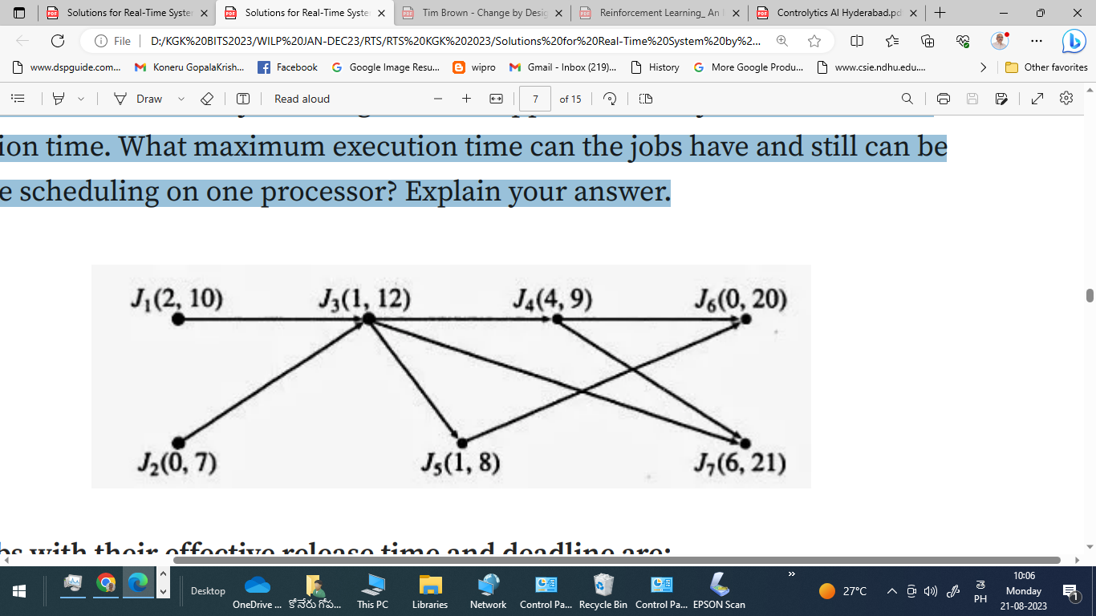

Q.2 Set (A)

Consider the set of jobs in the figure below listed with feasible intervals. Suppose that the jobs have identical execution time. What are their ERT (Effective Release Time) and Deadlines? (List in the format as J1 (ERT, ED)). What maximum execution time can the jobs have and still can be feasible scheduling on one processor? Explain your answer. [6M]



Q.2 Set (C)

Consider the set of jobs in the figure below listed with feasible intervals. Suppose that the jobs have identical execution time. What are their ERT (Effective Release Time) and Deadlines? (List in the format as J1 (ERT, ED)). What maximum execution time can the jobs have and still can be feasible scheduling on one processor? Explain your answer. [6M]



Q.3 Set (A)

Consider two processes *P*1 and *P*2 where for P1 *(p*eriod, execution time) = (50, 25) and for *P*2 (75,30). Which algorithm (RMA or EDF) can be used to schedule these two processes and why? Write the sequence of scheduling (according to whichever schedulable algorithm) in the format (example): P1,1 (t) 🡪 P1,2 (t) 🡪 … and P2,1 (t) 🡪 P2,2 (t) 🡪… where P1,1 refers to Job1 of Process1, and ‘t’ refers to scheduling time (on X-axis of Gant chart). Write schedule for the first 2 jobs of each Process. [6M]

Q.3 Set (B)

Consider two processes *P*1 and *P*2 where for P1 *(p*eriod, execution time) = (50, 25) and for *P*2 (75,30). Which algorithm (RMA or EDF) can be used to schedule these two processes and why? Write the sequence of scheduling (according to whichever schedulable algorithm) in the format (example): P1,1 (t) 🡪 P1,2 (t) 🡪 … and P2,1 (t) 🡪 P2,2 (t) 🡪… where P1,1 refers to Job1 of Process1, and ‘t’ refers to scheduling time (on X-axis of Gant chart). Write schedule for the first 2 jobs of each Process. [6M]

Q.3 Set (C)

Consider two processes *P*1 and *P*2 where for P1 *(p*eriod, execution time) = (50, 25) and for *P*2 (75,30). Which algorithm (RMA or EDF) can be used to schedule these two processes and why? Write the sequence of scheduling (according to whichever schedulable algorithm) in the format (example): P1,1 (t) 🡪 P1,2 (t) 🡪 … and P2,1 (t) 🡪 P2,2 (t) 🡪… where P1,1 refers to Job1 of Process1, and ‘t’ refers to scheduling time (on X-axis of Gant chart). Write schedule for the first 2 jobs of each Process. [6M]

Q.4 Set(A)

In a priority driven system, there are 3 tasks A, B and C. B and C are assigned equal priority and B and C are assigned lower priority than A. All the three tasks run continuously. They neither share any resource among themselves nor they preempt themselves. These three tasks are ready to be scheduled at the same time. Please determine the share of the processor, each of these tasks will get. Justify your answer with appropriate reason. If you make any assumptions, then state them clearly in the answer. [6M]

Q.4 Set(B)

In an interrupt-driven priority based RT system, there are 3 tasks A, B and C. B and C are assigned equal priority and B and C are assigned lower priority than A. All the three tasks run continuously. They neither share any resource among themselves nor they preempt themselves. These three tasks are ready to be scheduled at the same time. Please determine the share of the processor, each of these tasks will get. Justify your answer with appropriate reason. If you make any assumptions, then state them clearly in the answer. [6M]

Q.4 Set(C)

In a priority driven system, there are 3 tasks A, B and C. B and C are assigned equal priority and A is assigned higher priority than B and C. All the three tasks run continuously and they don’t preempt themselves. These three tasks are ready to be scheduled at the same time. Please determine the share of the processor, each of these tasks will get. Justify your answer with appropriate reason. If you make any assumptions, then state them clearly in the answer. [6M]

Q.5 Set (A)

5.1 A real time system is getting overloaded due to increase in the arrivals of the jobs. What design changes should you make in order to handle this situation? [3M]

5.2 In a round-robin system, there are 6 equally important tasks, each with a maximum execution time of 500 ms and the time quantum is 30 ms, and every context switch costs 2 ms, then find out the response time of each task. [3M]

Q.5 Set (B)

5.1 The CPU utilization of Hard-RT System is approaching 110% at times due to rapid arrivals of several jobs. What design changes should you make in order to handle this situation? [3M]

5.2 In a round-robin system, there are 6 equally important tasks, each with a maximum execution time of 500 ms and the time quantum is 30 ms, and every context switch costs 2 ms, then find out the response time of each task. [3M]

Q.5 Set (C)

5.1 A real time system is getting overloaded due to simultaneous arrivals of several Hard-RT jobs. What design changes should you make in order to handle this situation? [3M]

5.2 In a round-robin system, there are 6 equally important tasks, each with a maximum execution time of 500 ms and the time quantum is 30 ms, and every context switch costs 2 ms, then find out the response time of each task. [3M]

###